Ryan Farruggia

CSC 35

Professor Ghansah

3 February 2021

Lab #4 – Division, Direct Console Output, and ASCII code

Image of source code before debugging (part 1/2):

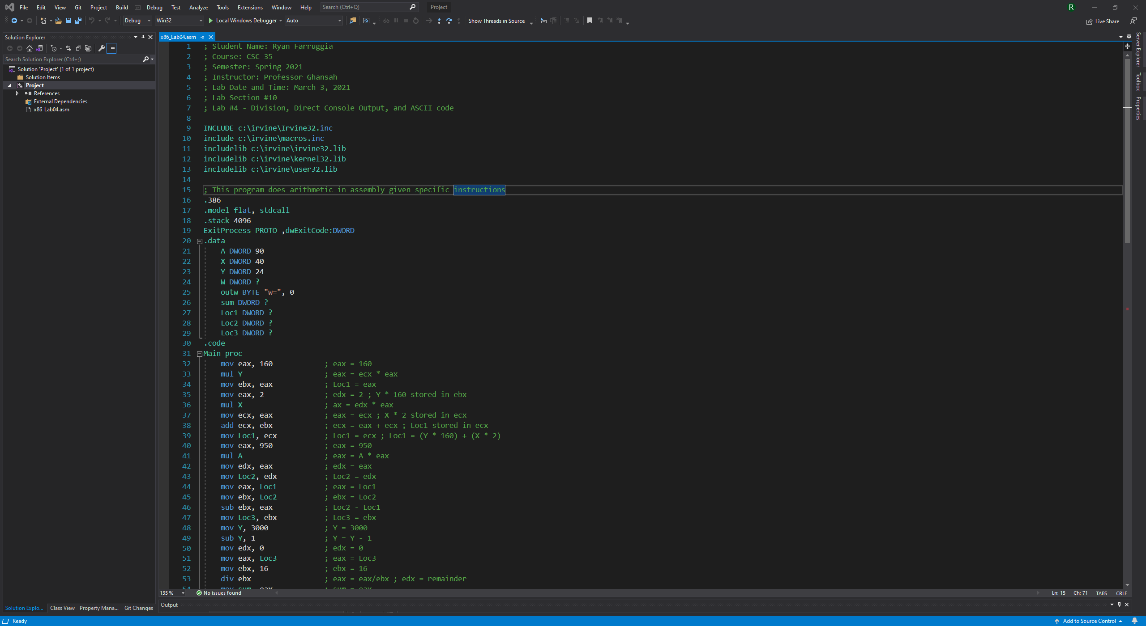

Image of source code before debugging (part 2/2):

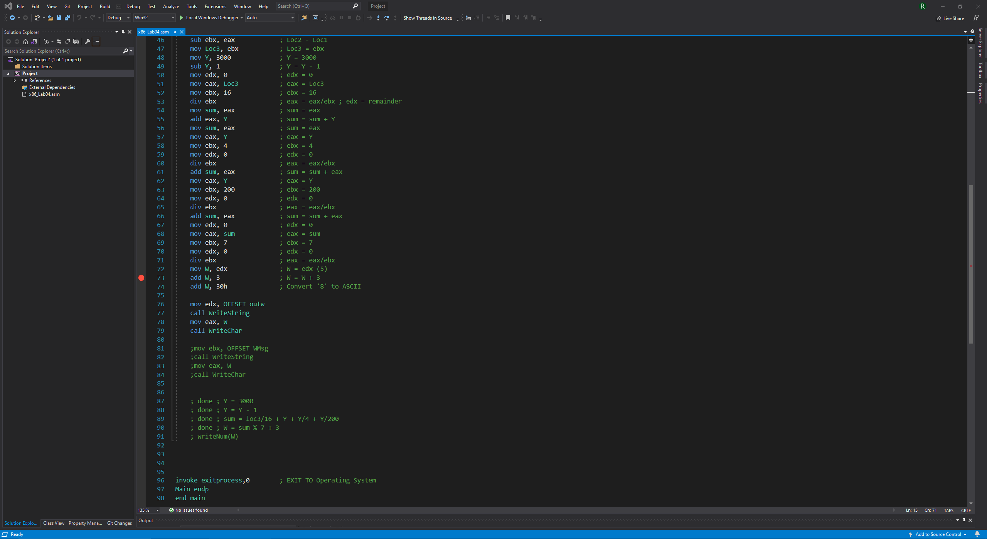

Debugging line 48 (mov Y, 3000) with all watch values and registers shown:

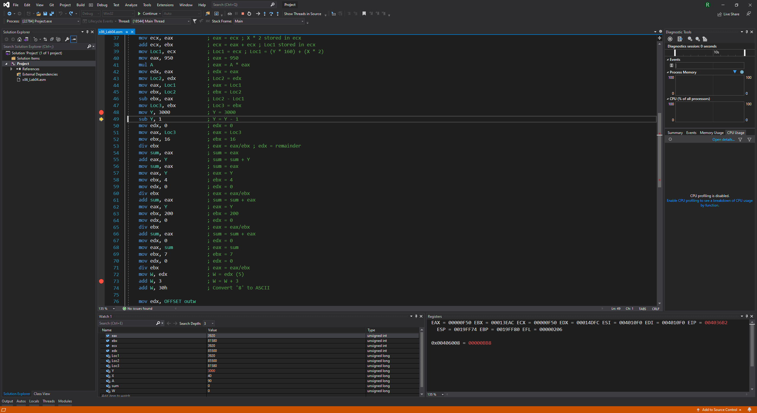

Debugging line 73 (add W, 3) with all watch values and registers shown:

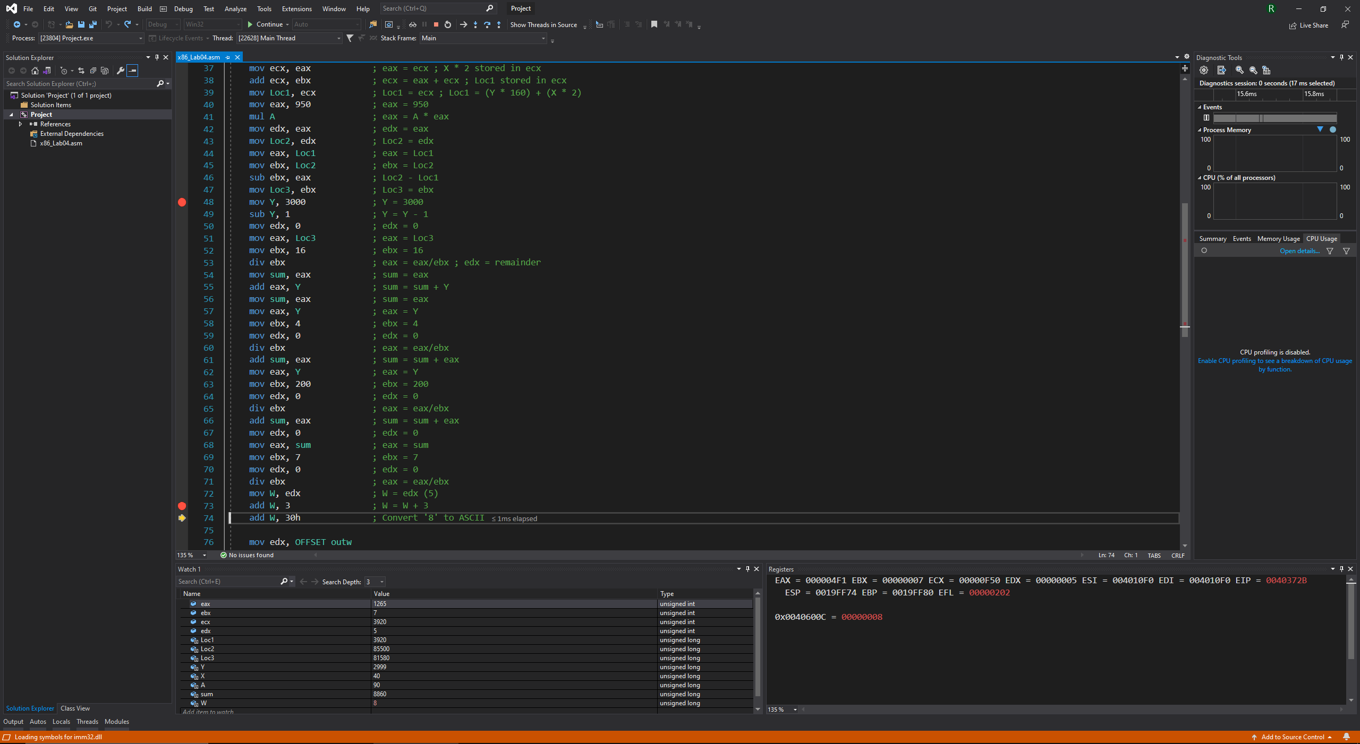

Debugging line 79 (call WriteChar) with output displayed in console as “w=8”:

